Never Say Never by Justin Bieber (with Jaden Smith)

- Listen and put the sentences in the correct order:
( ) I never thought that I could take the burn.
( ) Until I reached the point of no return.
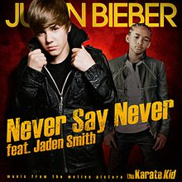
( ) I never had the strength to take it higher,
( ) See, I never thought that I could walk through fire
( ) It's my destiny.
( ) And there's just no turning back,
( ) Gonna give everything I have,
( ) When your heart's under attack,
2) Unscramble the words to make sentences:

CHORUS:
will/ say/ I never / never!
__________________________________
forever/ I / fight /will / till!
__________________________________
Whenever you knock me down,
I will not stay on the ground.
Pick it up,
Pick it up,
Pick it up,
Pick it up up up,
And never say never.
3) Unscramble the letters:
I never ________ (hotguht) that I could feel this power.
I never thought that I _________ (clduo) feel this free.
I'm __________ (onstrg) enough to climb the highest tower.
And I'm fast enough to run across the _______ (sae).
And there's just no turning _________(acbk),
When your heart's under attack,
Gonna give everything I have,
Cause this is my __________ (dienyst).
CHORUS
Here we go!
Guess who?
J Smith and JB!
I gotcha lil bro.
I can handle him.
Hold up, alight?
I can handle him.
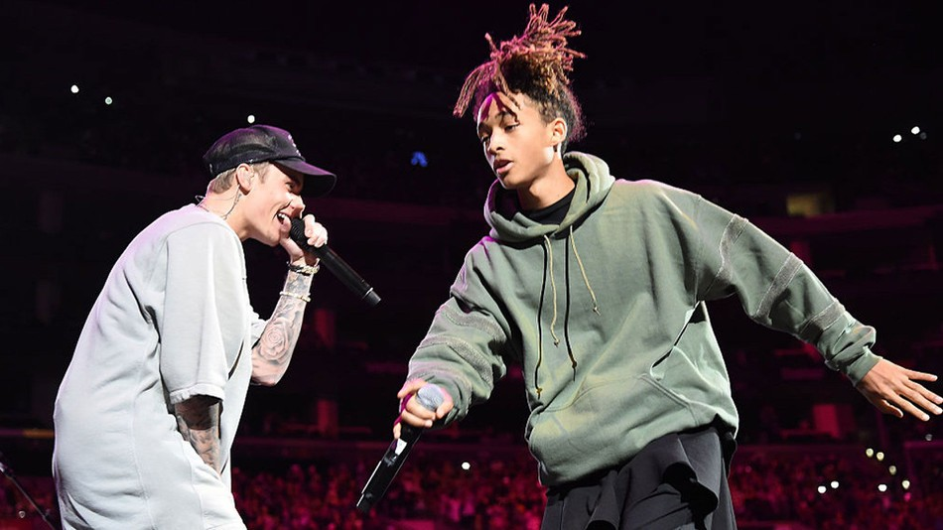
4) Complete the gaps with the comparative form of the adjective in parenthesis:
Now he's ________ (big) than me,
_________ (Tall) than me.
And he's _________ (old) than me,
And _________ (strong) than me.
And his arms a little bit _________ (long) than me.
But he ain't on a JB song with me!
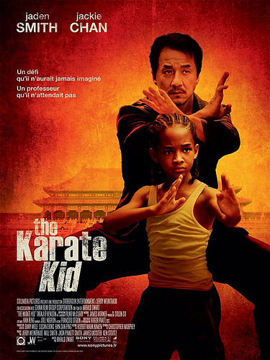
5) Listen and circle the correct option:
I be (crying/ trying / writing) a chill
They be trying to side with the thrill.
No pun intended, (was / were / be) raised by the power of Will.
Like Luke with the force, when push comes to shove.
Like Cobe with the (10th/ 14th/ 4th), ice water with blood.
I gotta be the (rest / best / worse),
and yes we are the flyest.
Like David and Goliath,
I conquered the giant.
So now I got the world in my (hand / head / feet),
I was born from two (Mars / stars / scars)
So the moon's where I land.
CHORUS 2X

